**Assignment-10(Mongo dB)**

Northwest Missouri State University is one of those universities that strive for student development and success. In this process, Northwest is organizing a few workshops regularly for students in different sectors.



So let’s imagine the list of a few workshops that they have decided to conduct in the year 2020 as shown below.

|  |  |  |  |
| --- | --- | --- | --- |
| **Name** | **Location** | **Duration (in hours)** | **GuestList** |
| Agro Development | Library | 2 | Dr. Jennifer Cervantes, Dr. L. Hubbard |
| Future planning | Zoom | 1 | Dr. Chi Lo Lim |
| CAD training | SU | 3 | Dr. Damon Leiss, Dr. David Kiene |
| International Culture Exchange | Library | 2 | Dr. David Kiene, Dr. Joy Daggs, Dr. Shandy Beck |
| Technical talk | SU | 4 |  |
| Political talk | Zoom | 2 | Dr. Matt Schieber |
| Financial Planning | SU | 3 | Dr. Rick Toomey, Dr. Cari Cline |
| Healthy food | Zoom | 2 |  |
| Photography talk | Library | 1 | Dr. Roger Von Holzen |
| Fitness club | Gym | 3 | DR. Lori Mardis, Dr.Ildiko Olasz |
| VidGrid Training | CITEite Office | 2 | Dr. McDonald Gary |

The list is still incomplete and many changes may be required. But at this point, we have to store this data using the Mongo database.

**Questions:**

1. Firstly create a new database named “NorthwestWorkshops”.

Sol.) use NorthwestWorkshops

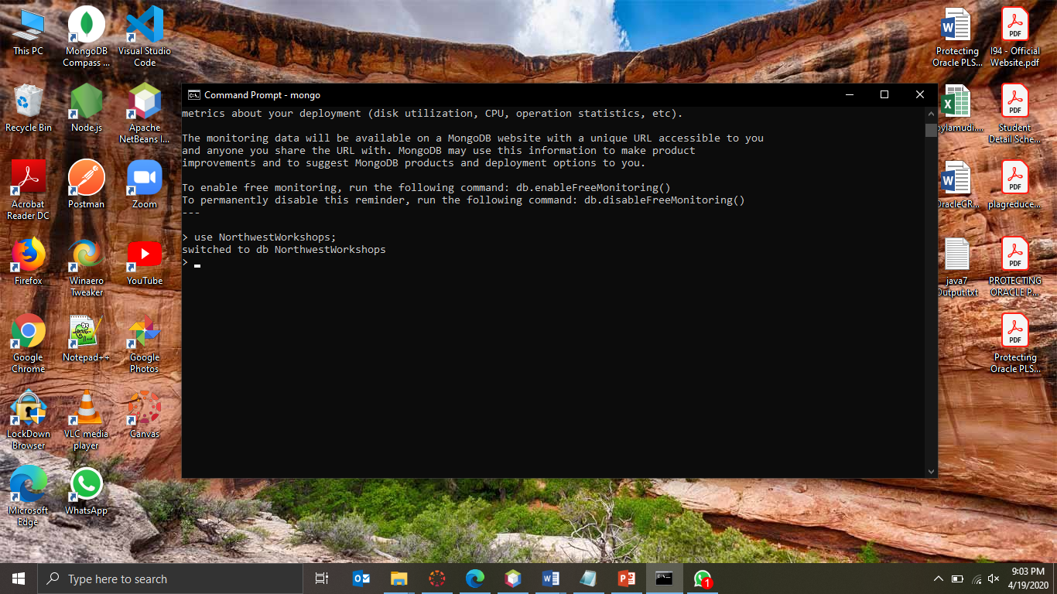

1. Now write a query to create a collection to store the documents and name it as “workshops”.

Sol.) db.createCollection(“workshops”)

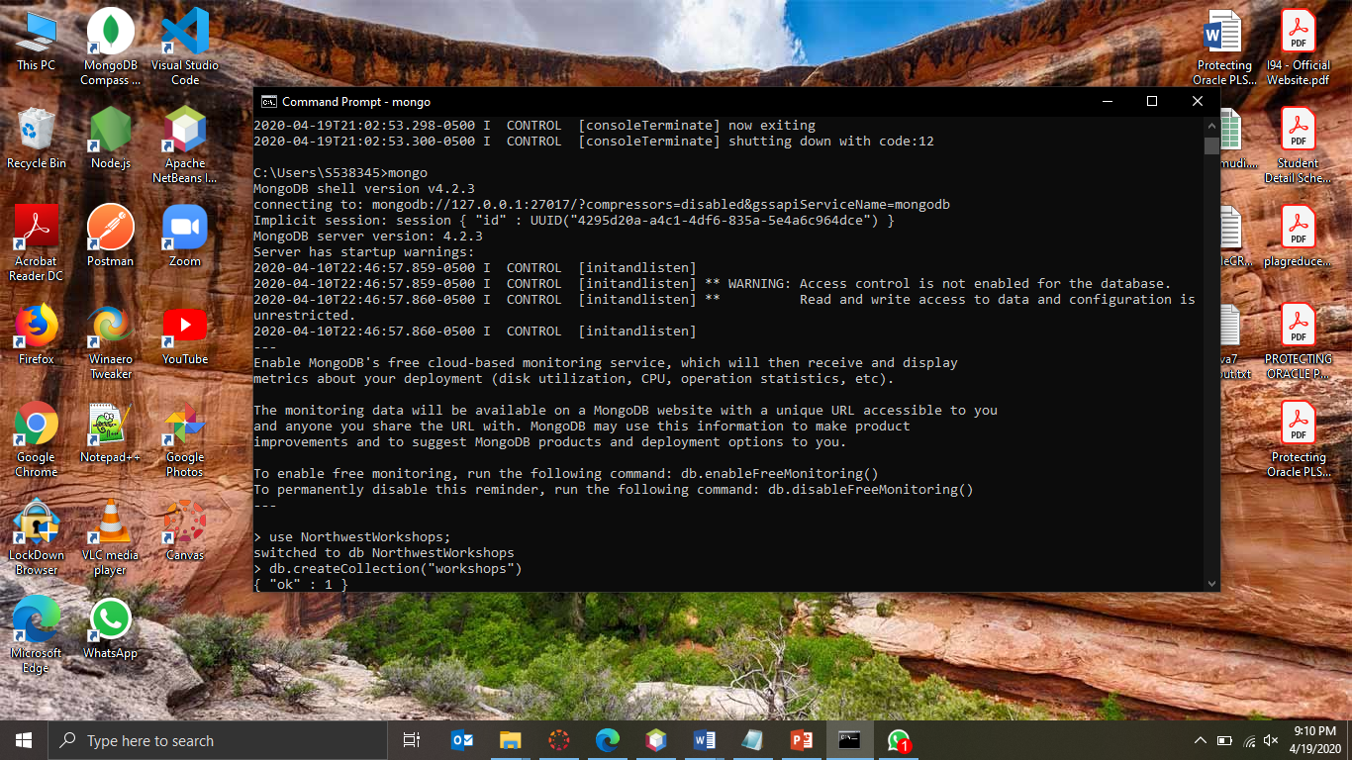

1. Now write a query to insert the first record from the table given in the table above.

Sol.) db.workshops.insert({ Name: “Agro Development”, Location: “Library”, Duration: 2, GuestList: [“Dr. Jennifer Cervantes”, “ Dr. L. Hubbard”] })

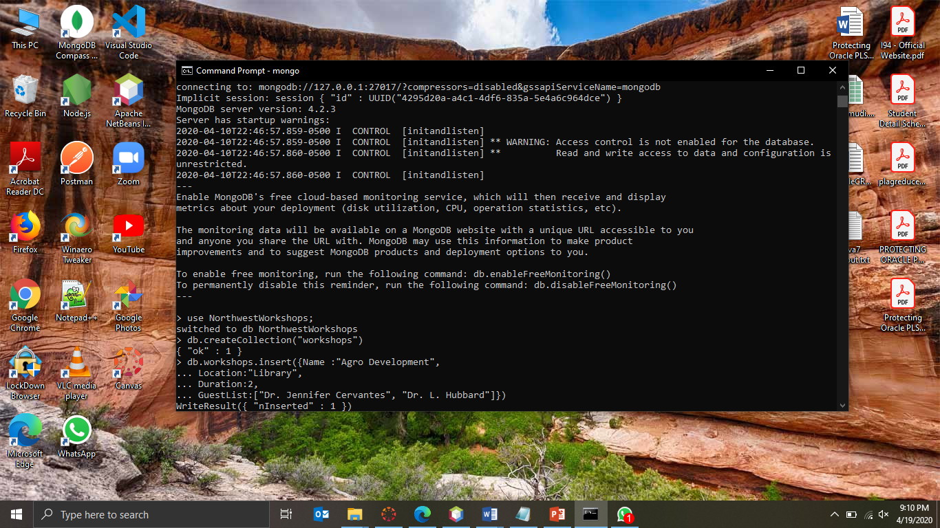

1. Now write a query to insert the rest of the data using only one command.

Sol.) db.workshops.insert([

{Name:"Future planning", Location:"Zoom", Duration:1 ,GuestList:"Dr. Chi Lo Lim"},

{Name:"CAD training", Location:"SU", Duration:3 ,GuestList:["Dr. Damon Leiss", "Dr. David Kiene "]},

{Name:"International Culture Exchange", Location:"Library", Duration:2 ,GuestList:["Dr. David Kiene", "Dr. Joy Daggs", "Dr. Shandy Beck"]},

{Name:"Technical talk", Location:"SU", Duration:4, GuestList:"" },

{Name:"Political talk", Location:"Zoom", Duration:2 ,GuestList:"Dr. Matt Schieber"},

{Name:"Financial Planning", Location:"SU", Duration:3 ,GuestList:["Dr. Rick Toomey", "Dr. Cari Cline"]},

{Name:"Healthy food", Location:"Zoom", Duration:2, GuestList:""},

{Name:"Photography talk", Location:"Library", Duration:1 ,GuestList:"Dr. Roger Von Holzen"},

{Name:"Fitness club", Location:"GYM", Duration:3 ,GuestList:["DR. Lori Mardis", "Dr.Ildiko Olasz"]},

{Name:"VidGrid Training", Location:"CITEite Office", Duration:2 ,GuestList:"Dr. McDonald Gary"}

])

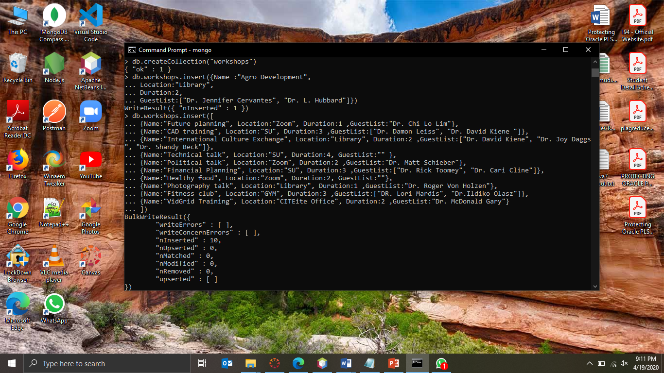

1. Now write a query to display the data using a single command.

Note: we have a method called pretty(), by which we can see the data in a better structure. Please use it.

Sol.) db.workshops.find().pretty()

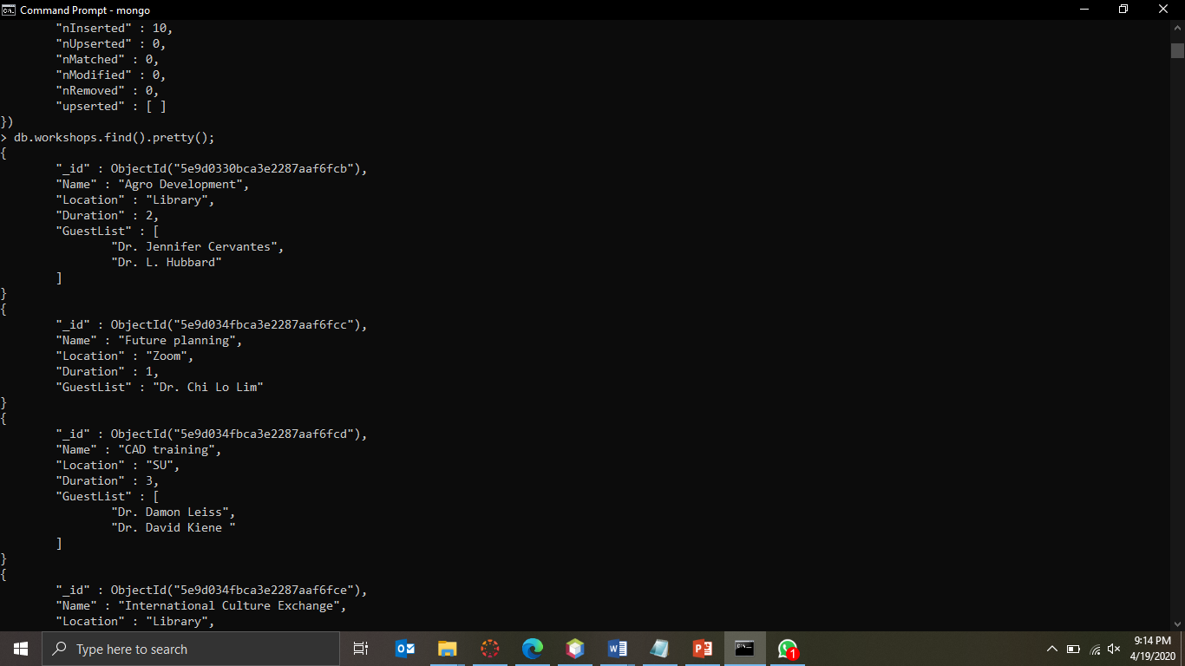

1. Write a query that prints the names of all the events conducted through “Zoom”.

Sol.) db.workshops.find({Location:"Zoom"}).pretty()

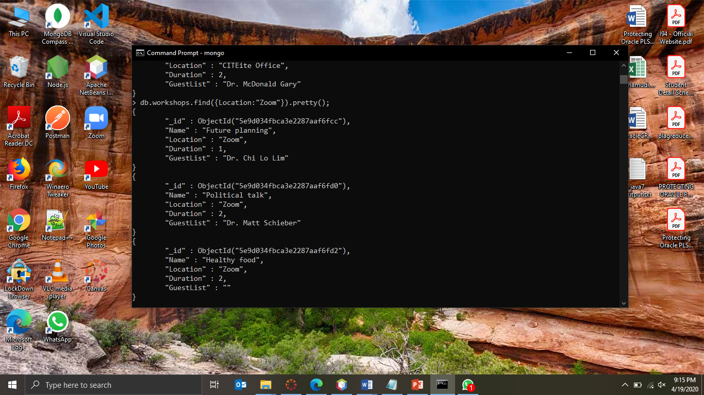

1. You can see that workshop named “Technical talk” does not contain any guest yet. Write a query to update the guest's name with “Dr. Von Holzen” in it.

Sol.) db.workshops.update( {Name: "Technical talk"},

{$set: {GuestList: "Dr. Von Holzen"}})

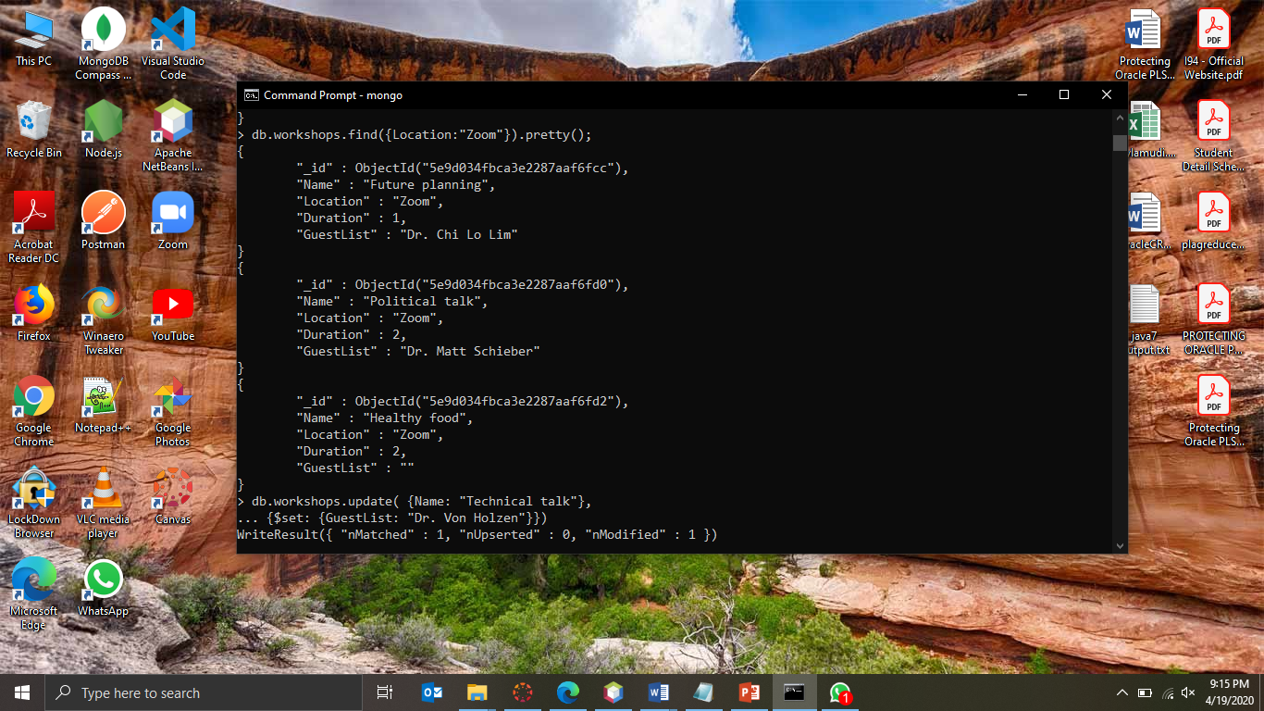

1. We got notification from an organizer stating that the event named “VidGrid Training” is going to conduct its meeting through Zoom instead of the CITEite office.

So, write a query to update this information.

Sol.) db.workshops.update( {Name: "VidGrid Training"},

{$set: {Location: "Zoom"}})

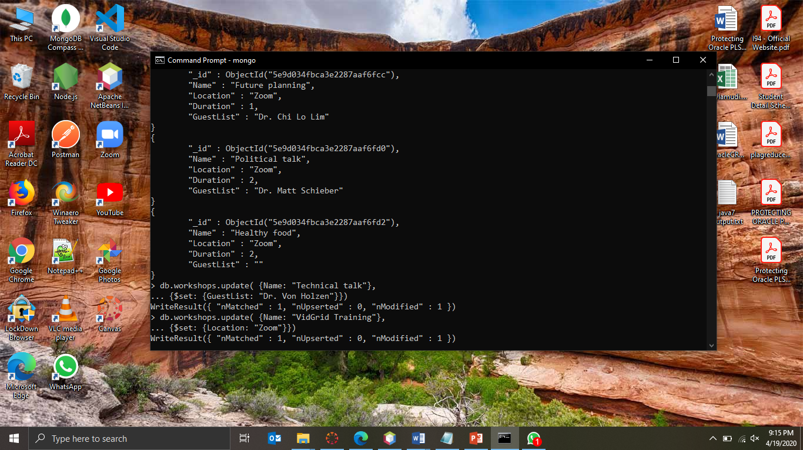

1. Use a forEach loop and print the names of the events where the duration of the event is more than 2 hours (search and find the syntax by yourself).

Sol.) db.workshops.find( { Duration: { $gt: 2 } } ).forEach( function(workshops)

{ print( "Name of the event: " + workshops.Name ); } )

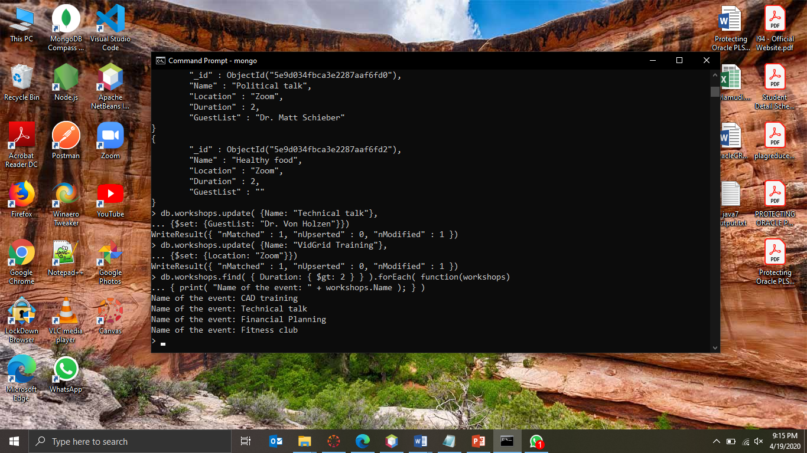

1. Write the differences between SQL and MongoDB.

Sol.) MondoDB:

* MongoDB is an open-source database developed by MongoDB, Inc. MongoDB stores data in JSON-like documents that can vary in structure. It is a popular NoSQL database.
* In MongoDB, each individual records are stored as ‘documents’.
* Documents belonging to a particular class or group as

stored in a ‘collection’.

SQL:

* SQL or Structured Query Language is a domain specific language used in programming and designed for managing data held in a Relational Database Management System (RDBMS).
* Records are stored in form of tables.
* Tables are directly stored into Database.

**For Submission:**

Make changes to this document and include your answers below each question. Also include the screenshots of all the queries you executed in this assignment. Rename the file to Lastname_Assignment10.doc and submit it through Canvas.